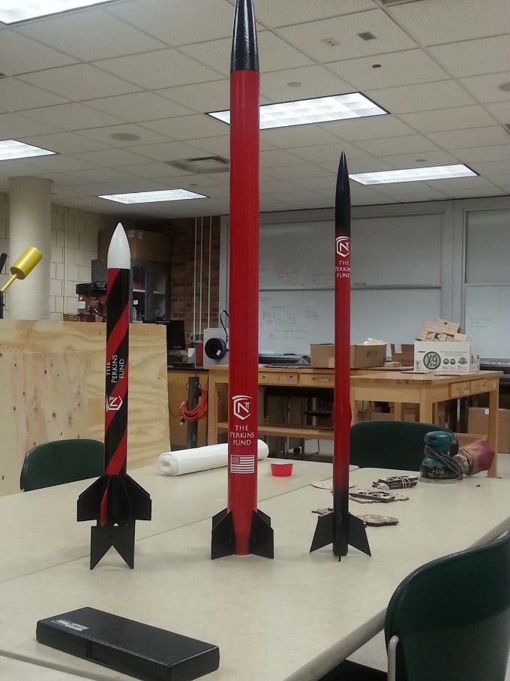

**Model Rocket Launch Report**

**NCC Roaring Lions**

**Normandale Community College**

**Maxwell Beck, Evin Connors, James Jones, Sam Kitzerow, Ali Minhas, Connor Smith, Caleb Sigfrid, Vadim Stavitskiy**

**Advisors: Dr. Susan Kasahara, Martin Stickney**

**Mentor: Gary Stroick**

**March 9, 2017**

TABLE OF CONTENTS

TABLE OF CONTENTS 1

INTRODUCTION 2

MODEL ROCKETS 2

APOGEE ASPIRE: 2

APOGEE ARACHNID: 3

SEMROC SLS ARCAS: 4

WEATHER CONDITIONS 5

LAUNCH AREA AND FLIGHT PATH 5

BUILDING PROCESS 7

A SUCCESSFUL LAUNCH DAY! 8

## 

INTRODUCTION

The content below demonstrates that the NCC Roaring Lions Rocket Team successfully designed, built, and launched commercially available model rockets. Three model rockets were built over the course of the fall and winter months. The model rockets built were the Apogee Aspire, Arachnid, and SLS Arcas. The Aspire and Arachnid were tested, as required by the Midwest High Powered Rocketry Competition, on the 20th of January at Miller Park in Eden Prairie, Minnesota. The weather conditions were overcast and the base level of clouds were present. Because the weather conditions were not ideal, we did not test the SLS Arcas rocket. A total of three launches were successfully attempted. These launches were performed with either Estes C or D Class Motors. The launches were performed at approximately 2:30pm.

MODEL ROCKETS

All off the rocket parameters were inserted into an Open Rocket simulation for both C and D Class motors.

APOGEE ASPIRE:

The Apogee Aspire is a low cost, high performance, level 2 model rocket that has an assortment of different motors to choose from. It is the thinnest rocket of the three, measuring in at about 29.0 inches in length and 1.2 inches in diameter. With the C Class motor, the Aspire simulation predicted an apogee altitude of 190 ft, a maximum velocity of 293 ft/s, and a max acceleration of 731 ft/s2. With the D Class motor, the Aspire had an apogee altitude of 515 ft, a maximum velocity of 413 ft/s, and a maximum acceleration 918 ft/s2. While trying to physically determine the center of pressure, this rocket was slightly damaged. We decided to re-run the OpenRocket simulation with an additional small set of 3 fins, whose main purpose was to 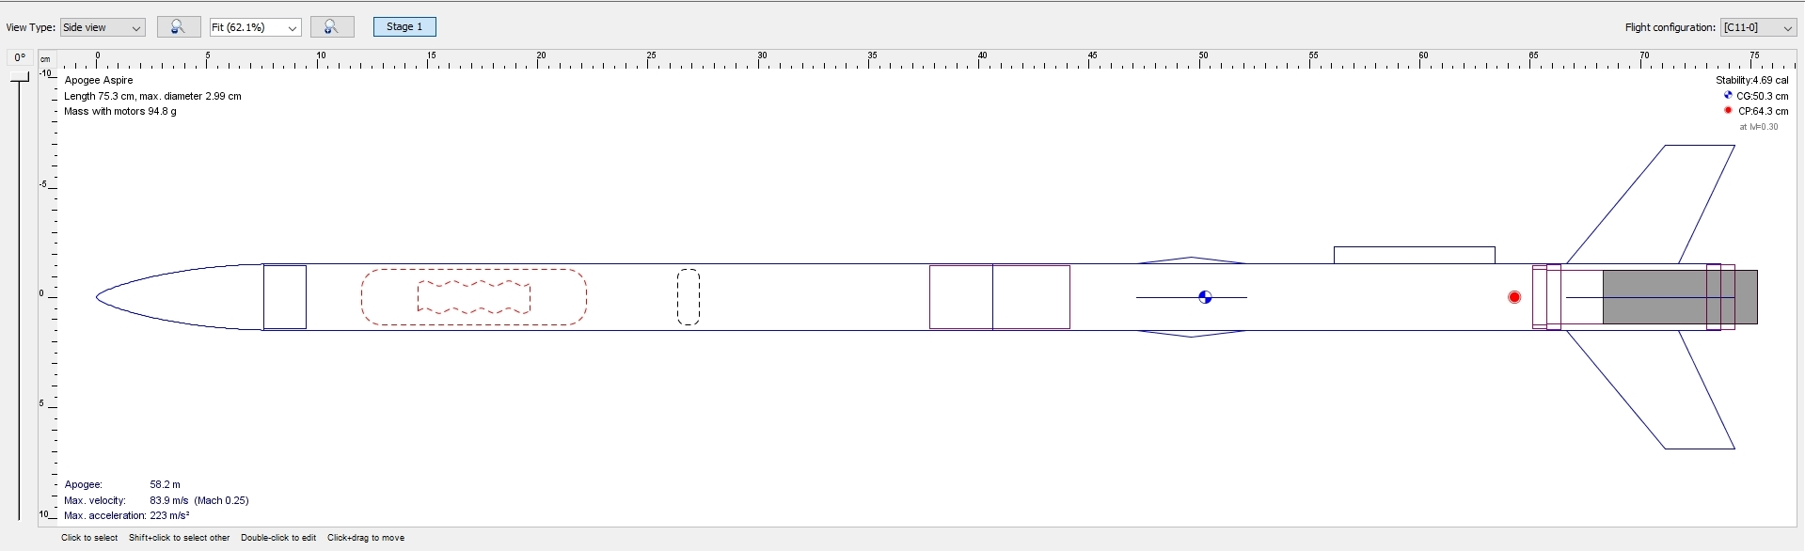structurally support the physical damage. The simulation didn’t show a significant change.

APOGEE ARACHNID:

The Apogee Arachnid is an eight-finned rocket that measures about 21.5 inches in length and 1.6 inches in diameter. With the C Class motor, the Arachnid had a predicted apogee altitude of 96.7 ft, a maximum velocity of 192 ft/s, and a max acceleration of 525 ft/s2. With the D Class motor, the Arachnid had an apogee altitude of 316 ft, a maximum velocity of 283 ft/s, and a maximum acceleration 663 ft/s2. While assembling this rocket we were not able to completely insert the motor mount into the rocket. To make sure that the rocket would be stable before launching it, we modified our OpenRocket file to take into the account the change of the motor mount position. The simulation came out with positive results which was confirmed with 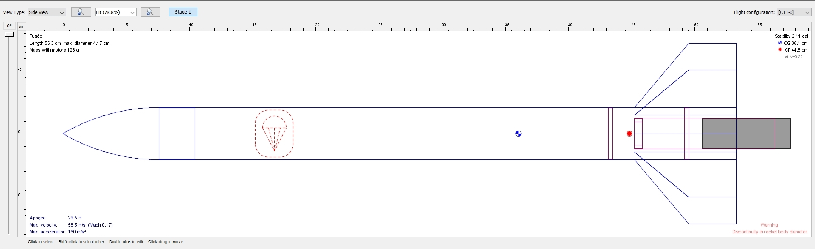multiple successful launches.

SEMROC SLS ARCAS:

The Apogee SLS Arcas was the largest commercial rocket the Roaring Lions built, measuring in at 45.5 inches in length and 2.25 inches in diameter. This rocket was modeled off NASA’s famous research rockets used in the mid to late 20th century. For this rocket we had decided to use an Aerotech F-22 motor. Upon trying to fit the motor into the motor mount, we discovered that motor’s diameter was greater than the mount. In order to make it work, we decided to not use the motor mount, but instead to press fit the motor directly into the inner tube. To achieve the perfect fit we wrapped small amount of masking tape around the motor and that made it work.

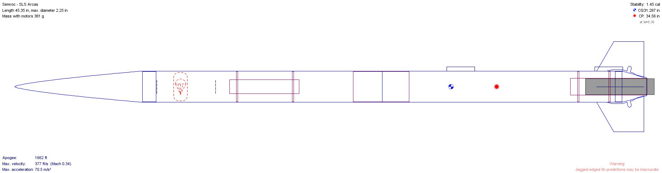

WEATHER CONDITIONS

January 20th, 2017; 2:53pm ([WeatherUnderground](https://www.wunderground.com/history/airport/KMSP/2017/1/20/DailyHistory.html?&reqdb.zip=&reqdb.magic=&reqdb.wmo=&MR=1))

|  |  |  |  |  |  |  |  |  |  |
| --- | --- | --- | --- | --- | --- | --- | --- | --- | --- |
| Temp | Windchill | Dew Point | Humidity | Pressure | Visability | Wind Dir. | Wind Speed | Precip | Conditions |
| 36.0 ℉ | 29.0 ℉ | 34.0 ℉ | 93% | 29.57 in | 5 mi | ESE | 9.2 mph | N/A | Overcast |

LAUNCH AREA AND FLIGHT PATH

**LOCATION:** Miller Park, Eden Prairie MN

**The Figure Below shows the location of the launch site as well as the locations of all three landings.**

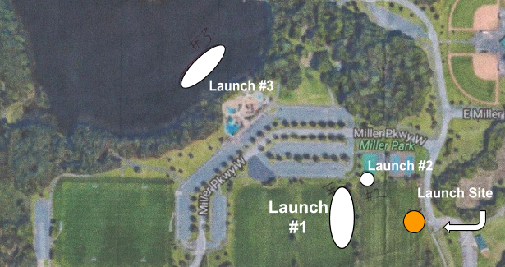

**LAUNCH #1** An Estes C-motor was used on the first launch. It was mounted on the Arachnid rocket. The rocket landed approximately 330 ft west of launch site.

**LAUNCH #2** Another Estes C-motor was used on the second launch. It was mounted inside the Aspire rocket. It traveled higher than the first as expected from the simulation and landed quite close to the first rocket.

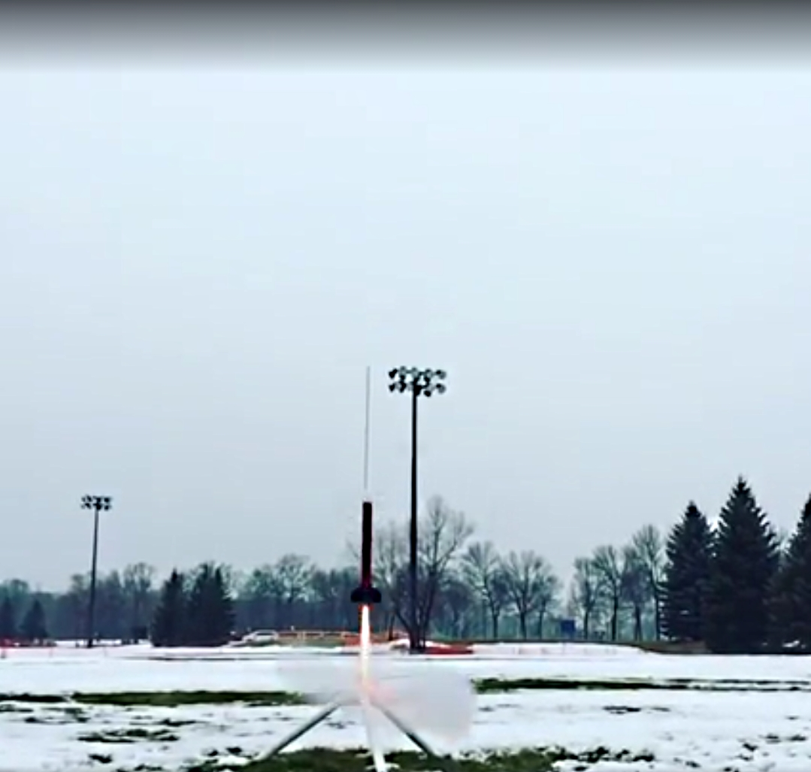**LAUNCH #3** We decided to move on to an Estes D-motor and mount this motor in the Arachnid rocket used in the first launch. This rocket traveled higher than the first two and landed about 1200 ft northwest from the launch zone. We had difficulty finding this rocket because of how far it landed from the launch site but were able to successfully recover it.

## BUILDING PROCESS

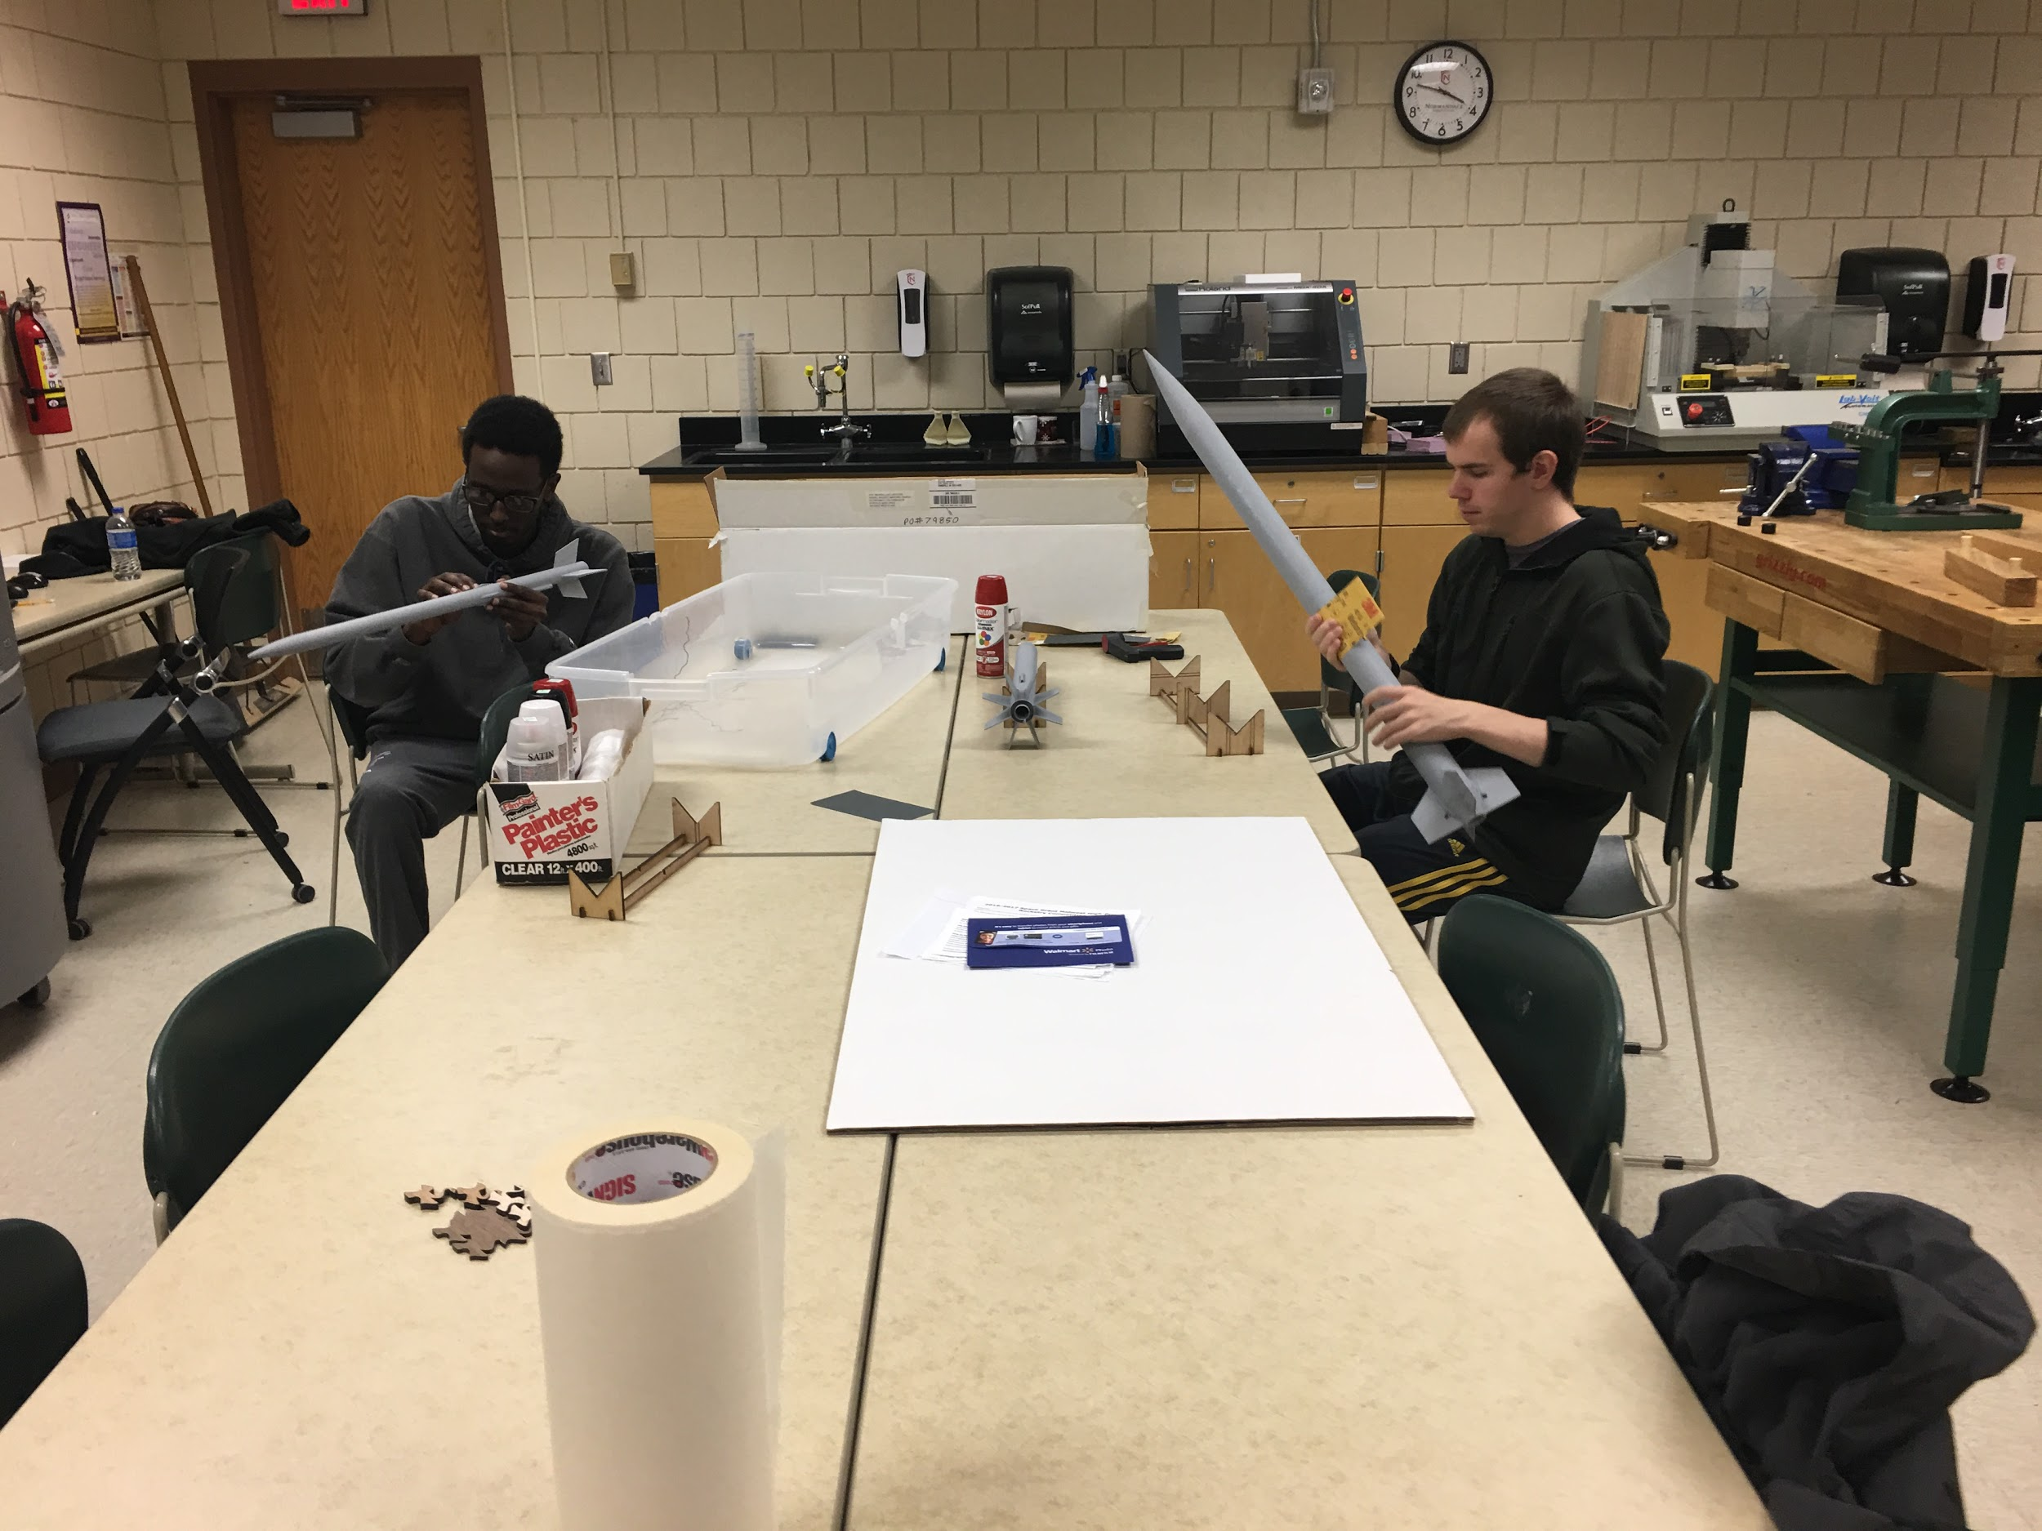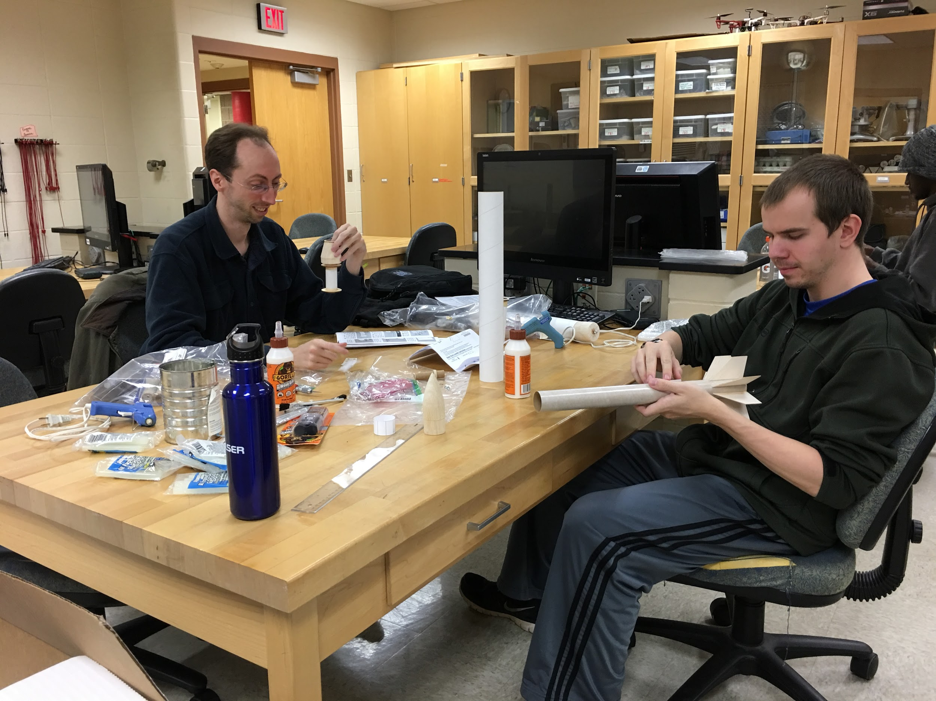

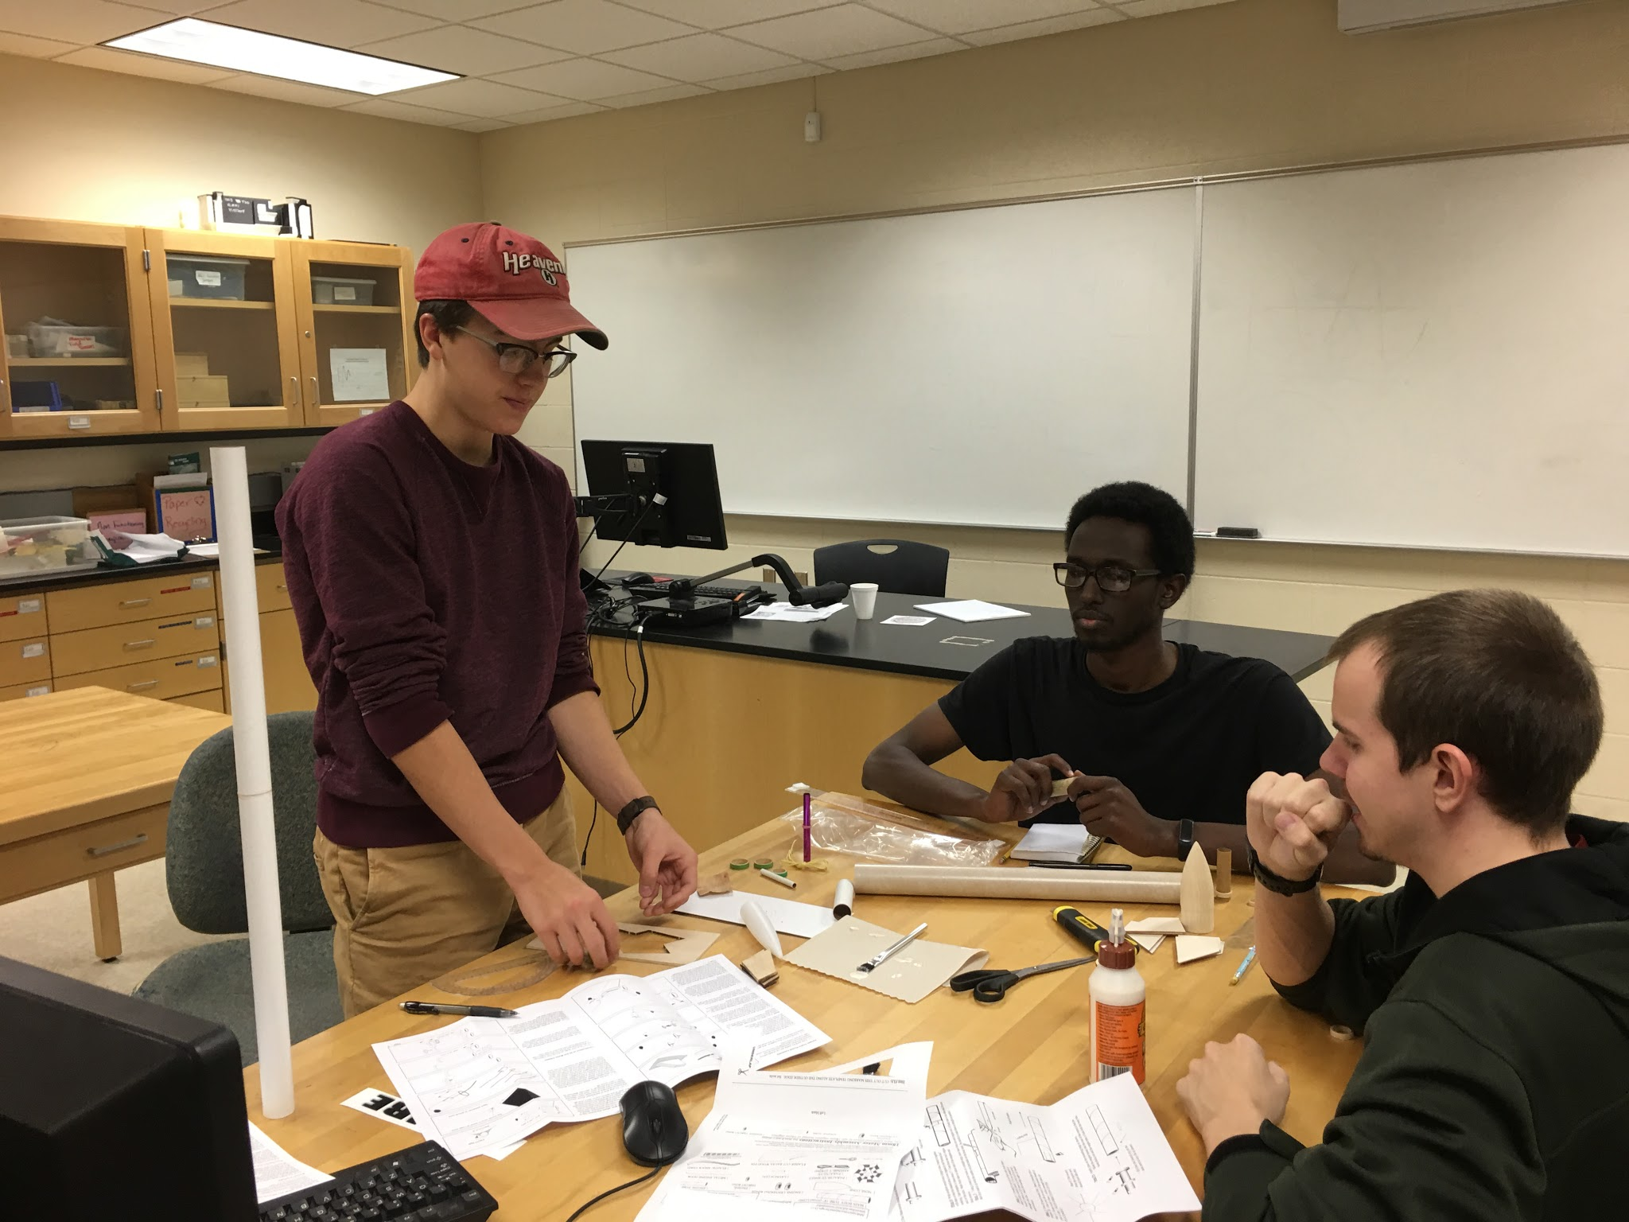

A SUCCESSFUL LAUNCH DAY!

